**Smart Attendance System using Raspberry Pi**

***Submitted in partial fulfillment of the requirement for the Degree of Bachelor of Technology***

in

### **Computer Science & Engineering**

By

**Rishabh Rajpurohit (9919103096)**

**Paul P. Jonathan (9919103121)**

**Yash Raj Gairola (9919103150)**

To

**Dr. Neeraj Jain**



Department of Computer Science Engineering and Information Technology Jaypee Institute of Information Technology

{Declared Deemed to be University U/S 3of UGC Act}  
A-10, Sector-62, Noida, India

October 2022

# **TABLE OF CONTENTS**

1. INTRODUCTION

1.1 General Introduction… 3

1.2 Problem Statement… 4

1.3 Novelty of the Problem… 5

1.4 Empirical Study… 6

1.5 Brief Description of the Solution Approach… 7

1.6 Comparison From Existing Approaches… 8

1. LITERATURE SURVEY

2.1 Summary of papers studied… 9

2.2 Integrated summary of the literature studied… 12

1. REQUIREMENT ANALYSIS AND SOLUTION APPROACH…

3.1 Solution Approach 13

1. MODELING AND IMPLEMENTATION DETAILS…

4.1 Implementation Details and Issue 19

**INTRODUCTION**

**GENERAL INTRODUCTION**

Attendance is the measure for calculating productivity whether you are at the workplace or college/university. It is meant to keep track of every individual’s availability. The traditional ways of recording an attendance involved maintaining a register and marking people present/absent on particular days. The process of maintaining attendance registers is a cumbersome task and is extremely difficult to track historical records as most of the registers find themselves stacked in cupboards in a degraded state.

With the advent of technology and its revolutionary changes, recording an attendance too has become tech-savvy. The smart attendance system in today's world is the best way to record attendance without any irregularities. Moreover, the historical records can be easily accessed at the touch of a button within a few minutes.

# **PROBLEM STATEMENT**

A smart attendance system is very crucial and important for any kind of business. A good and efficient attendance system helps in monitoring the punctuality of employees and managing the absence of people. A smart attendance system enables setting up the attendance workflows and maintaining a proper validation of employee time-sheets.The system can be configured in mobile devices and the managers can have a track of the employee’s location if required.The smart attendance system saves a lot of time and money and is highly secure process in maintaining the database in the server. We aim to make a smart attendance system based on facial recognition. Our aim is to make this system more convenient and feasible. We plan to replace webcam with raspberry pi camera as raspberry pi is quite cheap and portable.

**NOVELTY OF THE PROBLEM**

Smart Attendance systems are not an anomaly nowadays. They are present in most of the companies/universities, basically every institution involving employees constitutes them. But our focus is based on how we can further optimize it or make it more convenient. Our idea is to use raspberry pi instead of webcam for facial detection. Raspberry pi is a series of small single-board computers developed by the Raspberry foundation. Raspberry pi is very cheap and wieldy along with its camera is capable of 2592 x 1944 pixel static images, and also supports 1080p.  But at the same time, there are some limitations associated like its ram is only 1 gb. also, we aim to make this project optimized for our college settings, and if given access we would like to integrate it with our webkiosk(College website).

# **EMPIRICAL STUDY/TOOL SURVEY**

1. **HAAR CASCADE**

***It is an Object Detection Algorithm used to identify faces in an image or a real time video***. The algorithm uses edge or line detection features proposed by Viola and Jones in their research paper “Rapid Object Detection using a Boosted Cascade of Simple Features” published in 2001. The algorithm is given a lot of positive images consisting of faces, and a lot of negative images not consisting of any face to train on them. The objective is to find out ***the sum of all the image pixels lying in the darker area of the haar feature*** and ***the sum of all the image pixels lying in the lighter area of the haar feature***. And then find out their differences.

1. **LBPH**

**Local Binary Pattern** (LBP) is a simple yet very efficient texture operator which labels the pixels of an image by thresholding the neighborhood of each pixel and considers the result as a binary number. It was first described in 1994 (LBP) and has since been found to be a powerful feature for texture classification. It has further been determined that when LBP is combined with histograms of oriented gradients (HOG) descriptors, it improves the detection performance considerably on some datasets. Using the LBP combined with histograms we can represent the face images with a simple data vector.As LBP is a visual descriptor it can also be used for face recognition tasks.

**Brief description of Solution Approach**

**Our project enables an organization to smartly manage and store attendance of employees/staff or students in case of educational organizations. It has features like offline backup storage as well as cloud storage. The user has to stand within 50cm of the device to be able to successfully detect his face and then our device matches the face with faces present in the database and then it fetches the list of events/classes and the eligible students/staff for attending the event. If the credentials match, then at last it fetches the attendance record sheet and creates a new column of date with current date and marks the person present. Then it stores the attendance record again offline as well as on cloud.**

**COMPARISON WITH OTHER APPROACHES**

**Basically, facial recognition is expensive to develop and the companies offering this service charge a lot of money. Also, services are not entirely directed towards a particular institution.**

**There is also the concern of privacy and identity theft.**

**We aim to counter all this by making it free, open source and free of cost.**

**LITERATURE SURVEY**

**SUMMARY OF PAPERS STUDIED**

1. **Paper 1**

* Face Recognition and Identification using Deep Learning Approach
* KH Teoh, RC Ismail, SZM Naziri, R Hussin, MNM Isa and MSSM Basir
* School of Computing and Informatics, Albukhary International University, Kedah Malaysia.
* School of Microelectronic Engineering, Universiti Malaysia Perlis, Perlis, Malaysia.
* Department of Electrical Engineering, Politeknik Mukah, Sarawak, Malaysia.
* https://iopscience.iop.org/article/10.1088/1742-6596/1755/1/012006/pdf

**Basically, authors here used haar cascade for face detection. They have found that there are several cases in which haar cascade does not detect faces which are a distance below 60 cm from the camera tha haar cascade do not detect faces.**

**For the model they have used convolutional and deep neural networks for the model which have accuracy of 91.7% in recognising images and 86.7% accuracy in video feed.**

**2) PAPER 2**

* Face Recognition System
* Shivam Singh, Prof. S. Graceline Jasmine
* Department of SCSE, Vellore Institute of Technology, Chennai, Tamil Nadu, India
* https://www.ijert.org/research/face-recognition-system-IJERTV8IS050150.pdf
* paper uses haar_cascade for frontal face detection
* preprocessing: face image is resized to 100x100 histogram normalization used to make image more clear
* db_storage: facial feature are stored in the database
* post processing: names are shown in video output
* This paper compares a few algorithms for facial recognition which are:

- Neural Networks

- Principal Component Analysis

- Eigenfaces

- Fisherfaces

* - Local Binary Pattern Histograms

**Basically , here they used KLT algorithm, viola jones used haar cascade classifier and PCA for feature extraction. In this project , they have also run some experiments on other facial recognition algorithms. They have found that the PCA algorithm outperforms all the other algorithms. And he has also acknowledged that poor lighting is a disadvantage here.**

**3) Paper 3**

 Face Recognition with Local Binary Patterns

Timo Ahonen, Abdenour Hadid, and Matti Pietik ̈ainen

Machine Vision Group, Infotech Oulu

PO Box 4500, FIN-90014 University of Oulu, Finland,

{tahonen,hadid,mkp}@ee.oulu.fi, http://www.ee.oulu.fi/mvg/

<https://www.researchgate.net/publication/221304831_Face_Recognition_with_Local_Binary_Patterns>

**In this paper, they have described an approach of recognising faces using local binary pattern histogram. They described how the approach of lbpf works, in lbpf there are several formulas for calculating distance between two histograms to find out the classification. In this paper, they have run some performance tests on several algorithms and distance measures, using the CSU face identification and evaluation system using the ferret test. the results of the test were that in LBP category, fb, fc and dup distance measures were outperforming the others with 79% accuracy and PCA was 65%, BIC 37% and 42% for EBGM.**

**INTEGRATED SUMMARY OF THE LITERATURE STUDIED**

Since, from all these research papers we can see that, lbph has the highest accuracy rate, across 10,000 + images and also is the easiest to implement. so, we have used lbph in our project. All the research papers have used haar cascade (viola jones algorithm) for face detection. One paper used an interesting approach by comparing different types of distances between histograms, to find out which distance is more optimized and give better results. for example, chi square distance, euclidean distance, manhattan distance etc. Chi square had the best results which was fascinating to know .

**REQUIREMENT ANALYSIS AND SOLUTION APPROACH**

**SOLUTION APPROACH**

**USE CASE DIAGRAM**

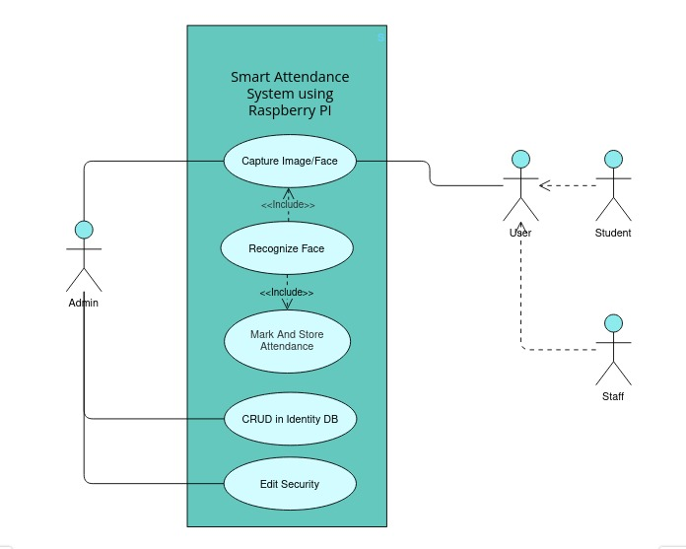

**ACTIVITY DIAGRAM**

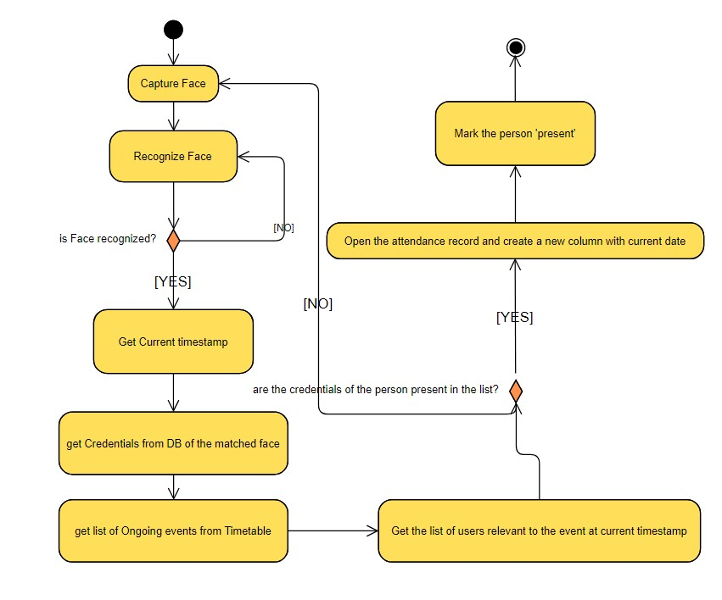

**DEPLOYMENT DIAGRAM**

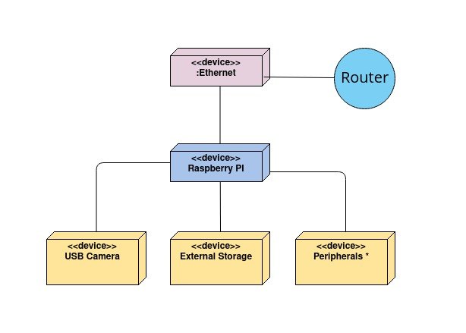

**COMPONENT DIAGRAM**

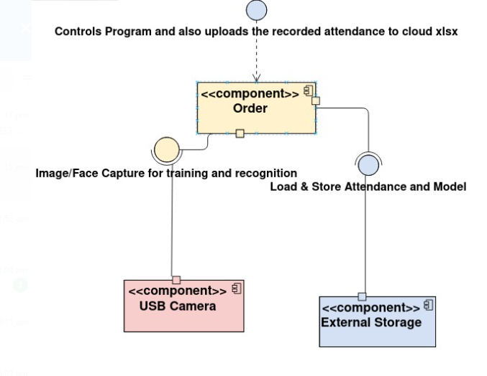

**STATE DIAGRAM**

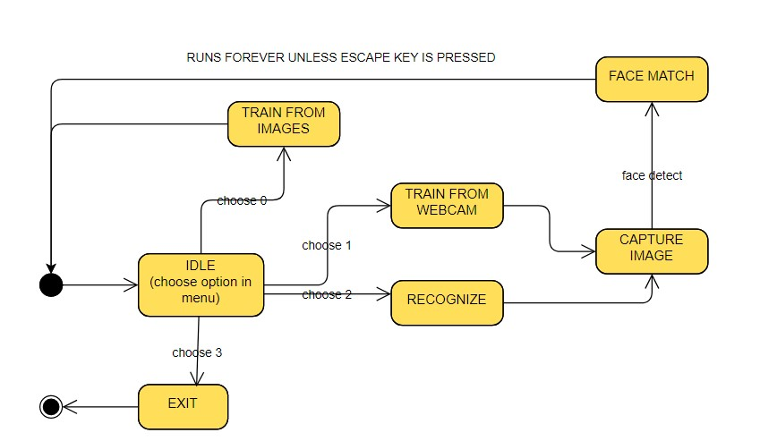

**MODELING AND IMPLEMENTATION DETAILS**

**IMPLEMENTATION DETAILS AND ISSUES**

In the Project code we have 2 methods of training:

1. training from images

The images are stored in a database folder and are each analyzed by the code, the faces are detected by the haar_cascade and stored in the data older under the same label and a model is trained based on these images

1. training from live camera feed

The program asks for a label name, The camera is turned on and the program captures images from the camera feed and detects faces using haar_cascade and stored in the data folder under the label name given

1. recognizing the person in front of the camera

The camera is turned on and the program captures images from the camera feed and detects face using haar_cascade and gives the faces to the model which finds the closest match and overlays the label on the camera feed and marks the attendance on the csv file